Machine learning 2019----------------------------

---- instalar Python

----instalr pip

WHERE python – pip (cmd)

Instalar -----









----------sacar datos

<https://www.quandl.com/>

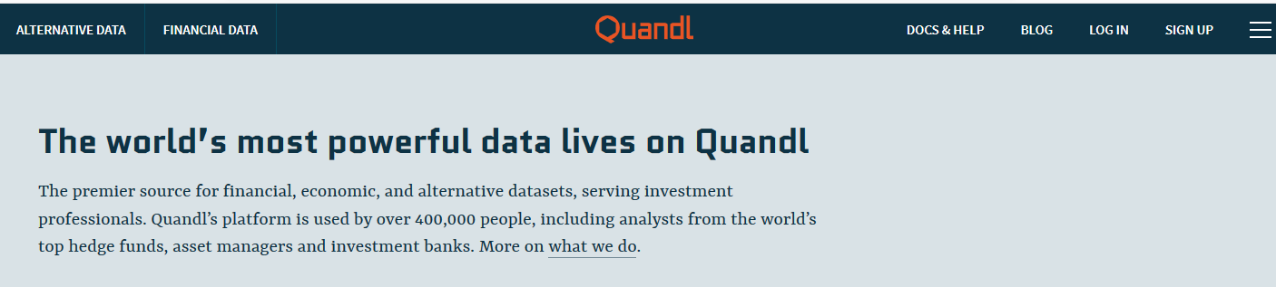

---------------------------------------------------------------------------------------------TRAER DATO

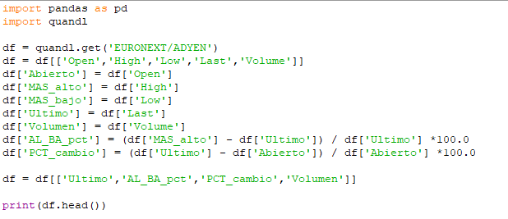

--------------------------------F5

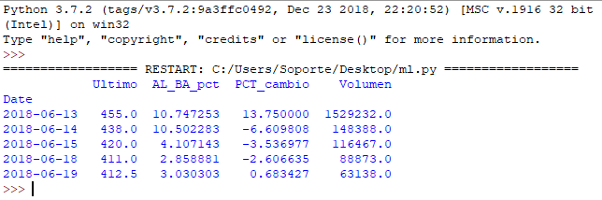

-------------------------segunda parte prediccion y presicion

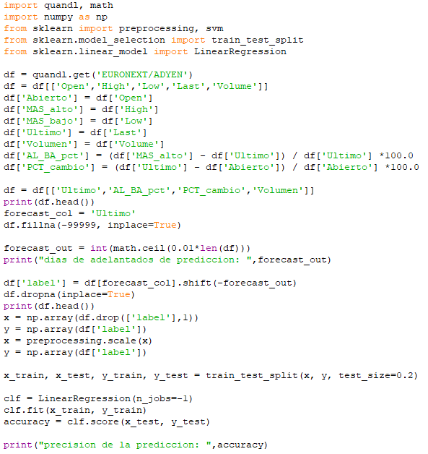

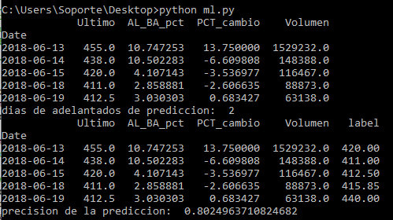

Capitulo 4